Smart Agriculture – AGROCASTURE

Ms. GOKILA BRINDHA S  AP(SrG), Department of CT-UG  Kongu Engineering College, Perundurai  brindha.ctug@kongu.edu  RAJA.S  Student, Department of CT-UG  Kongu Engineering College, Perundurai  raja2003ss@gmail.com |  | JOTHISANKAR.E  Student, Department of CT-UG  Kongu Engineering College, Perundurai  jothishankar73@gmail.com  SRE NIRANJAN KUMAR. K.B  Student, Department of CT-UG  Kongu Engineering College, Perundurai  sreniranjankumarkb.20bcr@kongu.edu

Abstract — Agriculture and fisheries are highly dependent on the climate. Nowadays the negative climate change effects are already being noticed, including an increase in temperature, climate change, invasive plants, and more frequent extreme weather events. In these situations, farmers face major losses in their crop yield and also harvesting. We have found a solution to reduce the problem faced by farmers by getting direct accurate weather forecasting from the Geo Positioning Satellites. Our title AGROCASTURE defines “AGRO” as plantation & tree studies, and “CASTURE” refers to detecting the climatic conditions based on their locality and predicting the probability of the weather. In the proposed work a disaster may be identified before it arrives, by these “FOOD BOWL” can be saved. Farmers and people get benefits from the food conversation in the future. This brings the idea of developing a mobile application for forecasting the weather condition to the formers so that they may take the necessary steps for protecting their yield. Here, we are using Android Studio as front-end and Java as back-end.

I. Introduction
Agriculture is one of the oldest and most important human endeavours is the process of raising crops and livestock to provide food, fibre, fuels, and other products necessary for human survival. The Global population is expected to increase from more than 8 billion people by 2025. The Global demand for agricultural products is expected to grow at an unprecedented rate in the coming decades. There is an urgent need for innovation in the field of agriculture to meet the increasing global demand for food and other agricultural products. One of the important innovations is "Smart Agriculture” which uses the Internet of Things (IoT) to help farmers to increase crop yields and optimize the use of their resources. One of the major challenges faced in agriculture is the impact of weather on crops and livestock. Extreme weather events such as droughts, floods, and hurricanes can have a devastating effect on crops, leading to reduced yields and loss of income for farmers. In addition, changes in weather patterns, such as extended periods of heat or cold, can also affect crop growth and animal health. These weather-related challenges can be mitigated through the use of advanced technologies, such as precision agriculture and weather forecasting, as well as through the adoption of sustainable farming practices that can help farmers to adapt changing weather conditions.
However, addressing the impact of weather on agriculture will require a collective effort from government, and farmers. As the climate changes, agriculture is increasingly facing a variety of challenges. One major challenge is the unpredictable and extreme weather events that are becoming more frequent and intense. This can include droughts, heatwaves, and floods, which can have devastating effects on crops and livestock. Droughts can result in reduced crop yields and lower-quality crops, as plants struggle to access the moisture they need to grow. In addition, droughts can lead to higher temperatures and increased evaporation, which can further exacerbate the problem. Heatwaves can also have negative impacts on agriculture. High temperatures can stress crops and reduce their yields, and can also cause plants to mature more quickly, reducing the time they have to produce the livestock’s. In addition, heat waves can increase the risk of pests and diseases, which can further harm crops and livestock. Floods can also be a major challenge for agriculture. Flooding can damage crops and infrastructure, and can also contaminate soil and water sources, making it difficult for plants and animals to thrive. In addition, floods can wash away topsoil, reducing its fertility and making it harder for crops to grow. To address these challenges, farmers are increasingly turning to a variety of strategies. These can include the use of drought-resistant crops, irrigation systems, and other technologies to help mitigate the effects of extreme weather events. In addition, many farmers are adopting sustainable and regenerative agriculture practices, which can help build resilience to climate change and improve the long-term health of the land.
II. LITERATURE REVIEW
Nyoman Putra Sastra [1] proposes using the Internet of Things as a platform in the establishment of a smart campus. To connect to the Internet, an infrastructure of communication networks, sensor nodes, and gateways is required. Each sensor node is in charge of collecting data from its surroundings. This paper proposes a wireless sensor network for environmental monitoring.
Harika Pendyala [2] proposes that agriculture has been practised for centuries in every country and is both a science and an art of nurturing plants. Now technology has been always evolving, and agriculture must follow with. Smart agriculture relies heavily on IoT. Sensors connected to the Internet of Things (IoT) are utilised to offer vital information about agricultural fields. The key benefit of IoT is that it can monitor agriculture by utilising sensor networks to retrieve data from many sensors put at various nodes and send information through wireless protocol. The proposed work is based on a smart farm IoT system driven by Node MCU.
Chirayu Pranav Darji, [3] proposes Humidity & Temperature Measurement in Smart HVAC Systems. HVAC stands for Heating, Ventilation, and Air Conditioning. The author outlines along the functioning of an HVAC system. The design of this mechanical system is essentially an attempt to manage and monitor the temperature of a room through heating and cooling. It also regulates the humidity ranges in that environment by managing the action and dispersion of vaccum inside the room. Costly sensors are necessary to determine the temperature and humidity. These are typical mechanical sensors that cannot provide any further services such as cloud support, data storage, and so on.
Lal Bihari Barik [4] creates an Internet of Things (IoT)-based on temperature and humidity by detecting gadget that provides an effective and reliable method for observe agricultural factors. The system also includes a mechanism for remedial movement and decision-making.
Farida Habib Samantha [5] offers a low-cost, readily available environment monitoring system that can monitor a variety of environmental indicators. An environmental air quality monitoring system may also be used in industry. There is a risk of hazardous gases contaminating the air in mining or heavy industries. In such dangerous scenarios, an environmental monitoring system may be able to save the workers' lives.
Muhammad Aziz [6] suggests a climate monitoring system based on IoT. An IOT-based climate monitoring system for rural regions is presented in this research. Suburbanites Village, which is subject to floods, landslides, and severe winds, was chosen as the location for IOT sensor deployment. As a result, wind, rainfall, and temperature sensors are deployed in IOT stations. According to inhabitants, severe winds always blow every year. For several days, the wind blew, making it impossible for inhabitants to leave their houses. This wind is blowing so hard that it might destroy the house's roof. However, no technology presently exists that precisely monitors changes in air pressure/wind speed in the vicinity.
Yanshori et al [7] suggest a lot-based temperature and humidity monitoring system for the smart biological garden. The primary goal of this study is to create an IoT-based temperature and humidity monitoring system for smart gardens. Temperature and humidity sensors detect environmental factors and are get going by a microcontroller. The actuator used is a spray pump, which sprays water into the air to lower temperature. Sensor data and actuator status are communicated to the server and may be seen on a smartphone. The data collected can be used for a number of purposes. The consequence is the effect of scatter on temperature reduction.
Asadi Venkata Mutyalamma [8] proposes Smart Agriculture utilising IoT to measure soil humidity, temperature, moisture, pH, and nutrient values. Nowadays, smart agriculture minimizes a variety of farming issues. Farmers obtain the necessary information and relevant data to monitor plant development through the use of the Internet of Things, which links various sensors, actuators, and other embedded devices. Quality crops have been provided depending on soil nutrient levels, moisture content, and the Ph. factor.

III. PROPOSED METHODOLOGY
The following represents the algorithm for the implementation of the proposed methodology.
Step1: Connect the sensors and NodeMCU in bread board.
Step2: Connect the VCC& GND of NodeMCU to the Power
Supply.
Step3: Connect DATA the output pin to the Arduino IDE.
Step4: Switch on all the devices and run the Arduino code.
Step5: The temperature and humidity sensed by the sensor is
displayed in the IDE and the same is stored in the
firebase database.
Step6: Run the mobile application.
Step7: Display the alert message to the user when there is any
abnormal condition.
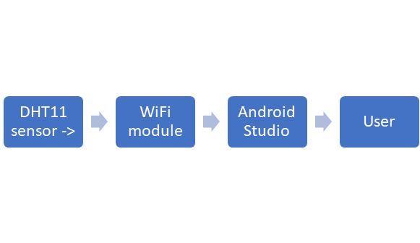
Figure 3. (a) Flowchart Representation of the model

Figure 3.a, denotes the flow chart of a working principle of the proposed System. The data sensed by sensor is send to the firebase through Arduino from firebase the temperature and humidity is shown to the user through mobile application.

CONNECTING DHT11 TO NODE MCU:

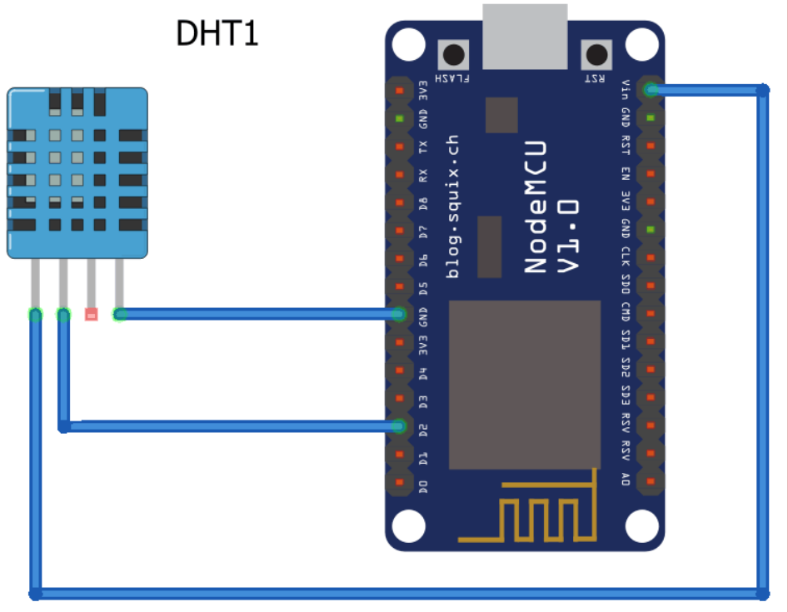
Figure 3. (b) A Schematic Representation of DHT11 and Nodemcu

- Get the hardware materials like DHT11 Sensor, a breadboard, NodeMCU board, and jumper wires.
- Connect the 3 pins to get the power supply and to store the data.
- Specifications of the Pins are:
VCC & GND = Power Supply
DATA = Used for retrieving the code from the Arduino IDE.
- The humidity and temperature measured by the sensors are converted and traversed in the form which is accepted by NodeMCU. From there it is sent to the system to detect the real-time disaster.
- Install the related software and libraries in Arduino so as to read the data from the sensors.
- The collected data are stored in the firebase database.
- Android App is developed to send the alert message to the user when an abnormality in the climate is detected. The application access the data from the firebase database.

CONNECTING NODE MCU TO FIREBASE:
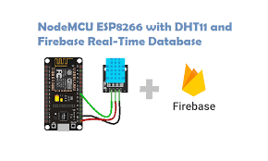410
Figure 3. (c) A Schematic Representation of DHT11 and Nodemcu

1. Create a new Firebase Project in Realtime Database Model.
2. Next Install an Arduino library on the Arduino IDE.
3. Connect a NodeMCU board on computer by using micro-USB cable.
4. Open the Arduino IDE and select the board and port.
5. Go to the "Library Manager" then install the "Firebase Arduino" library.
6. Create a new sketch in the Arduino IDE and put the code there.
7. Upload the sketch to your NodeMCU board.
8. Once the sketch has been uploaded to NodeMCU board will be connected to your Firebase project.

STEPS TO CONNECT FIREBASE TO THE ANDROID APPLICATION:

- After the Completion of an Application Interface to be Developed.
- Select the tools required for creating a link between android Studio and Firebase.
- TOOLS > FIREBASE > REALTIME DATABASE:
Steps to connect the Firebase: -
- Login to the firebase service for cloud data transfer process.
- Connect the Realtime Database to Application.
- Read the data from firebase and display it in the app.
DHT11
The DHT11 sensor is a temperature and humidity sensor that is commonly used in IoT applications. It is a digital sensor that detect the ambient air. It uses a thermistor and a capacitive humidity sensing element. The sensor emits a digital signal that can be read by a microcontroller, such as an Arduino, and then interpreted and displayed on a computer or other device.

The DHT11 sensor is widely used in a variety of applications, such as weather stations, air conditioning systems, and greenhouse environments. Both sensor and module versions of the DHT11 humidity and temperature sensor are available. This sensor may be distinguished from the module by a pull-up resistor and a power-on LED. Relative humidity is measured via the DHT11 sensor. A capacitive humidity sensor with a thermistor is used in this sensor to measure the surrounding air. 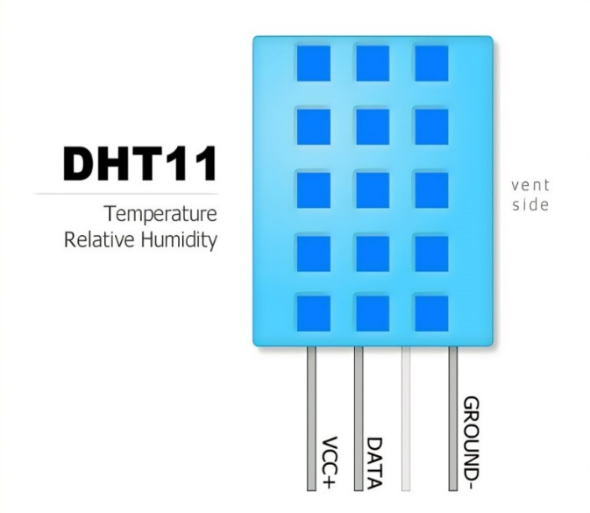
Figure 4. (a) Data Humidity and Temperature Sensor

NODEMCU

NodeMCU is an open-source IOT platform based there is an ESP8266 Wi-Fi microcontroller. It is a low-cost, low-power platform that enables developers to quickly and easily create IoT applications. NodeMCU comes with a number of built-in modules, including a temperature sensor, a humidity sensor, and a light sensor, all of which can be easily integrated into IoT projects. It also has an integrated Wi-Fi module, which allows for easy internet and device connectivity.

NodeMCU is widely used in IoT applications such as home automation, environmental monitoring, and smart agriculture. There are 30 total pins on the NodeMCU ESP8266, 17 of which are GPIO pins. The acronym GPIO stands for General Purpose Input Output. There are nine digital pins labelled D0-D8 and one analogue pin labelled A0, which is a 10-bit ADC. The D0 pin can only read and write data and has no additional capabilities.

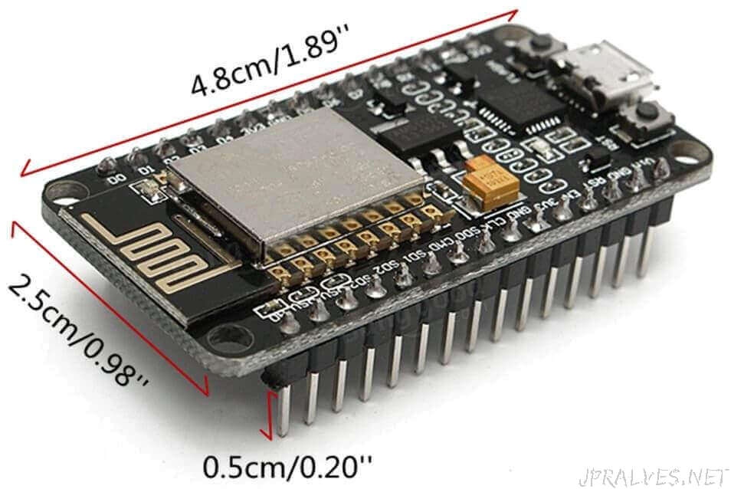
Figure 4. (b) NodeMCU

The ESP8266 chip is turned on when the EN pin is pushed HIGH. The chip consumes the least amount of power when it is pulled LOW. The board has a 2.4 GHz antenna for a long-range network, and the CP2102 chip serves as the USB to TTL converter.
The development board features an ESP-12E module with an ESP8266 chip with a 32-bit LX106 RISC CPU with a configurable clock frequency of 80 to 160 MHz and support for RTOS. There's also 128 KB of RAM and 4MB of Flash memory which should be plenty to handle the lengthy strings that make up web pages, The ESP8266 is outfitted with an 802.11b/g/n HT40 Wi-Fi transceiver, which allows it to not only connect to a Wi-Fi network and communicate with the Internet, but also to build its own network and let other devices to connect to it directly. This expands the ESP8266 NodeMCU capabilities.

V. EXPERIMENTAL RESULT ANALYSIS

To develop a user-friendly environment for communicating with the user between the Activities and Fragments, utilise Android Studio to create an activity. By including attributes such as login credentials allowing the user to detect their account and get access.

Making a fragment like Temperature and Humidity for a Data to be saved in the format of presenting a data in the interface. Each fragment is connected to the firebase in order for the data to be represented in the user interface. The limited data levels and alerts to users must be individually tailored based on their own needs. The mobile application displays the saved temperature and humidity. An alert message is sent to the user if there is a significant change in the temperature and humidity.

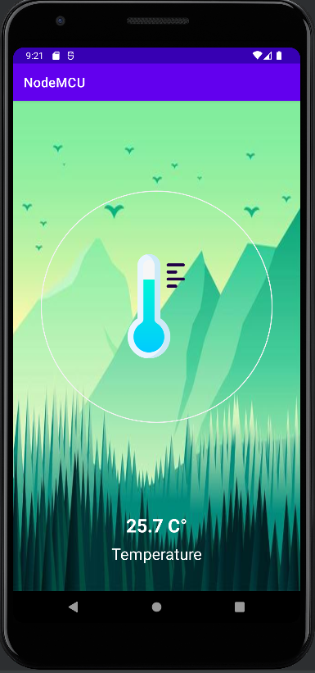
Figure 5. (a) Displaying the Data of a Temperature

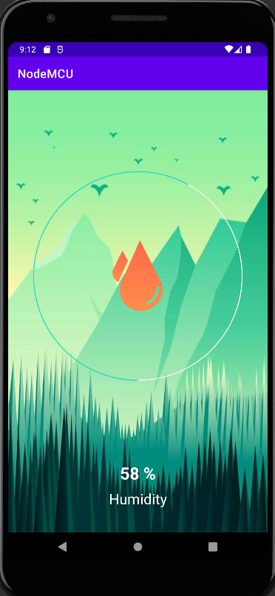

Figure 5. (b) Displaying the Data of a Humidity

Notification Produced by Application

If the temperature and humidity deducted or arised state as an above limit of the user defined data, it alerts the user to be notified. In the form of designed notification box to be delivered to the user’s view.

VII. CONCLUSION AND FUTURE WORK
From this Application Farmers can easily predict their habitation climatic conditions. Using this application, farmers can easily come to know about the sudden change in the climate. If there is a need to make any steps to protect their crops and harvestings, the farmer can start at the earliest. Timely protection of the crop in the field or harvestings in the godowns help the farmers to reduce from the losses due to climatic conditions.

They can avoid the food wastage due to overflow of the rainfall on the non-seasonal time period by the form of the IoT Sensors to be detected and displayed the data in the time period of the real time-based events in the interval of Data of Temperature and Humidity Observed by the Sensors.

- To Update the various features like develop it with the help of rain sensor, soil sensor. So as to monitor the other factor affecting yields.

- Integrating with other applications and services, such as social media platforms, to allow users to share weather information and alerts with their friends and followers.

References

- Nyoman Putra Sastra and Dewa Made Wiharta, “Environmental Monitoring as an IoT Application”, International Conference on Smart Green Technology in Electrical and Information Systems (ICSGTEIS), October 2016.
- Harika Pendyala and Ganesh Kumar Rodda,” IoT Based Smart Agriculture Monitoring System”, International Journal of Scientific Engineering and Research, July 2021, Volume 9 Issue 7.
- Chirayu Pranav Darji, “IoT Based Sensor for Humidity and Temperature Measurement in Smart HVAC Systems”, International Journal of Recent Technology and Engineering, January 2021, Vol-9 Issue-5.
- Dr. Hetal Patel and, Dr. Shailesh Khant, “Smart Irrigation system for Precision Farming”, Turkish Journal of Computer and Mathematics Education ,2021 April 28, Vol.12 No.10.
- Lal Bihari Barik Department of Information Systems, “Temperature and Humidity Controlling using Arduino”, International Journal of Advanced Computer Science and Applications, 2019 Vol. 10, No. 9.
- Muhammad Aziz Muslim, “IOT Based Climate Monitoring System”, IOP Conference Series, June 2020, Vol 746.
- Nesma Abd El-Mawla, “IoT for the Failure of Climate-Change Mitigation and Adaptation and IIoT as a Future Solution”, World Journal of Environmental Engineering, February-March 2019, Vol. 6, No. 1, 7-16.
- Assistant Professor D. Betteena Sheryl Fernando, “Smart Agriculture Monitoring System Using Iot”, International Journal of Scientific Research & Engineering Trends, July-Aug-2020, Volume 6, Issue 4.

